Odoo Administration – Apps (Modules)

# What are Apps?

Odoo apps are python modules that add features and functionality to the system. An app may contain its own entities or expand on other modules. Apps can ‘inherit’ other apps to safely modify or add fields, views and functions of the original app. Apps can also have dependencies of other apps so its important to know whether an app depends on another app before installing or uninstalling the app as it may install/uninstall those dependency apps too.

# Installing Apps

The built-in apps or modules are located in the ‘Addons’ folder on the server. In addition, one or more folders can be added to be home to all the additional apps or modules that can then be used in Odoo. These folders can also be linked via github and updated as needed.

Once a new module is placed in the addons folder (or folder designated for additional modules), the Odoo services need to be restarted. Only then will Odoo recognize the additions.

* Apps can be installed and uninstalled via the Apps icon.

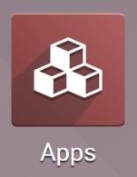

* If adding a newly added app, the app list needs to be updated.
  + In the **Apps** module, enter debug mode.
  + Click the **Update Apps List** button in the menu.

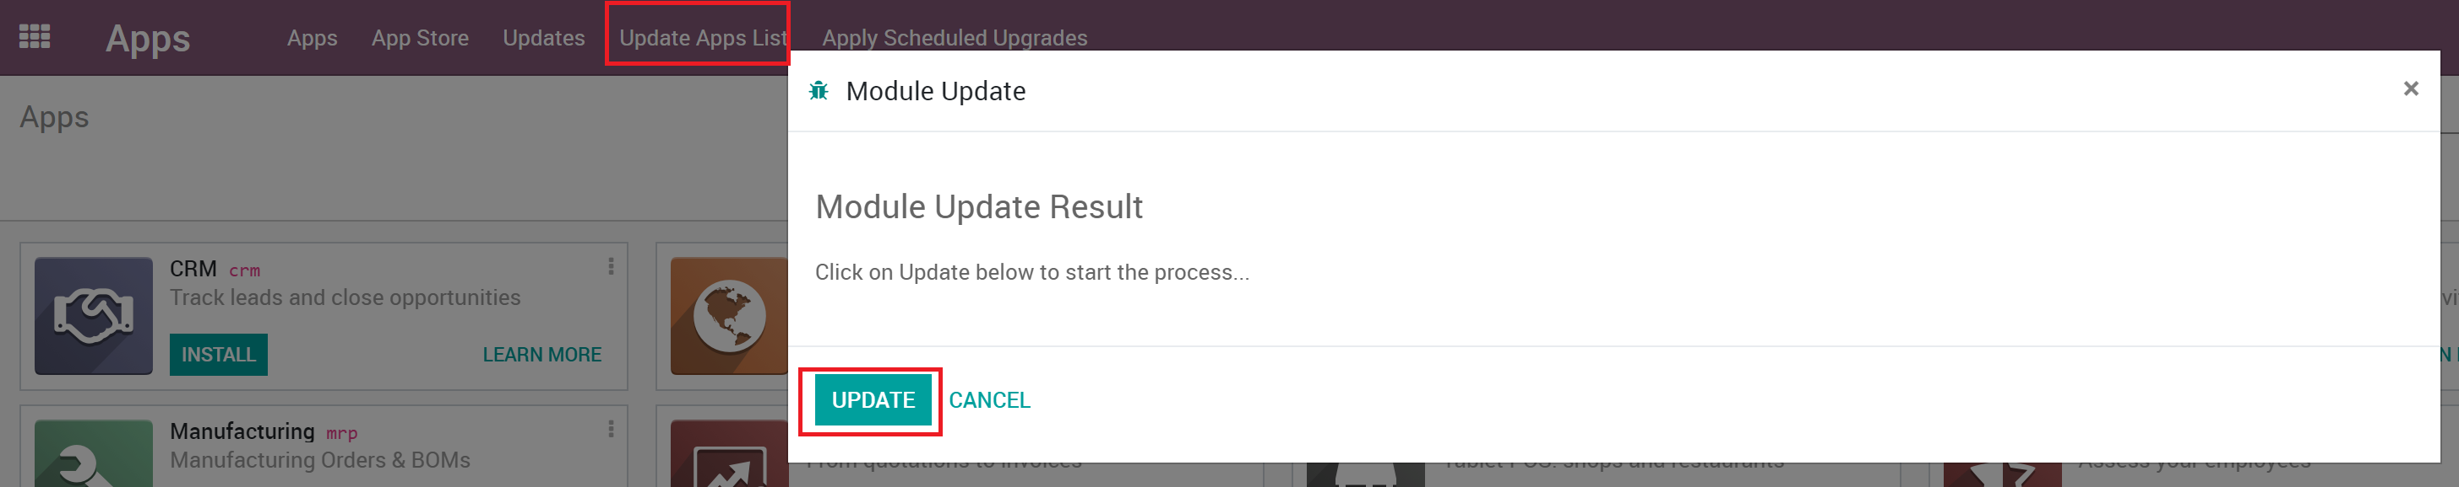

* + Click the **Update** button.
  + You may need to refresh your browser after the update finishes.
* You can find your App and click the Install button.

**Note**: Not all apps show as Apps as they may be marked as extensions to apps. Use the Odoo filters to find the app if you don’t see it at first.

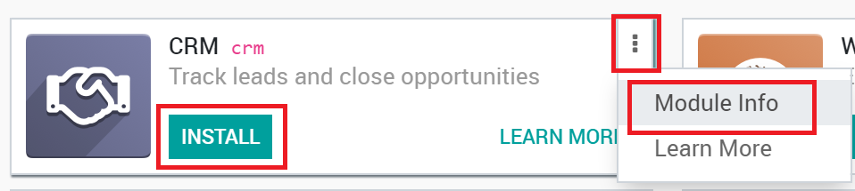

* Once installed, you may need to update users permissions for them to start using the app.

# Uninstalling Apps

**Warning:** Make sure you first test what you are about to do on a **duplicate** of your database before making any changes (especially installing/uninstalling apps).

In your Odoo instance click on **Settings**; in this app, you will be able to see how many applications you have installed. Click on **Browse Apps** to access the list of your installed applications. You can also click the **Apps** icon on the main menu.

 or 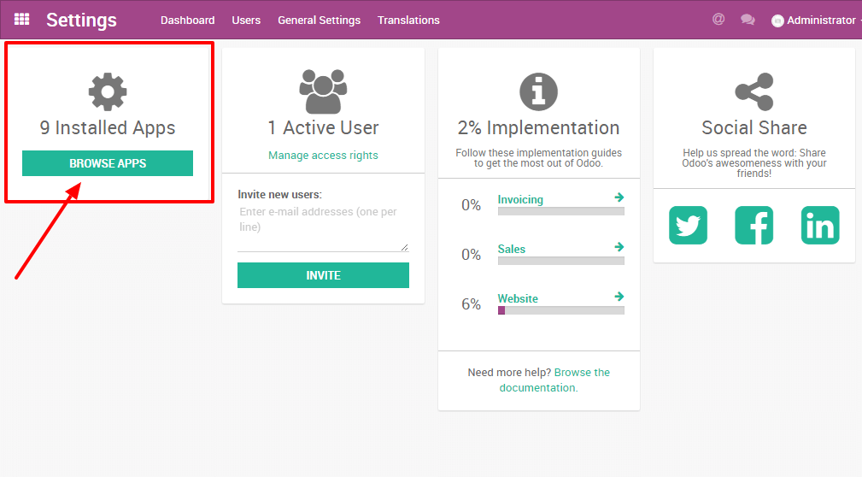

In your applications' dashboard, you will see all the icons of your applications. Click on the application you want to uninstall. Then, on the form of the application, click on **Uninstall**.

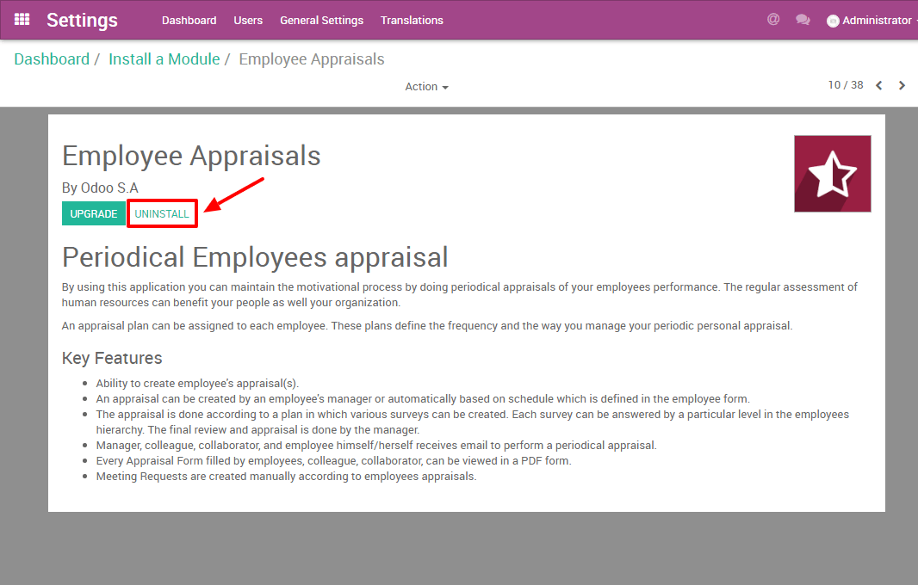

**Danger:** Some applications have dependencies, like Invoicing, eCommerce, etc. Therefore, the system will give you a warning message to advise you of what is about to be removed. If you uninstall your application, all its dependencies will be uninstalled as well (and the data in them will permanently disappear). If you are sure you still want to uninstall it, then click Confirm.

Last, after having checked the warning message (if any), click **Confirm**.

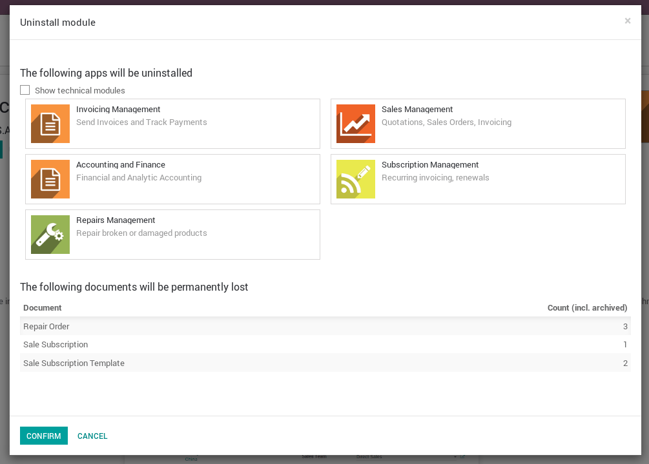

You have finished uninstalling your application.

# Good to know

* **Uninstalling apps, managing users, etc. is up to you**: no one else can know if your business flow is broken better than you. If we were to uninstall applications for you, we would never be able to tell if relevant data had been removed or if one of your business flow was broken because we do not know how you work and therefore cannot validate these kinds of operations.
* **Odoo Apps have dependencies**: this means that you may need to install modules that you do not actively use to access some features of Odoo you might need. For example, the Website Builder app is needed to be able to show your customer their Quotes in a web page. Even though you might not need or use the Website itself, it is needed for the Online Quotes feature to work properly.
* **Always test app installation/removal on a duplicate** (or on a free trial database): that way you can know what other apps may be required, etc. This will avoid surprises when uninstalling or when receiving your invoices.